**MGT2009 FINANCIAL MANAGEMENT ASSIGNMENT - 1**

NAME: T. Sai Pranathi

REG NO:22BCB7210

SLOT: D1

**ABOUT INFOSYS**

Infosys is a global leader in next generation digital services and consulting. It can enable clients in more than 56 countries to navigate their digital transformation. With over four decades of experience in managing the systems and workings of global enterprises, it expertly steer clients, as they navigate their digital transformation powered by the cloud. It can enable them with an AI-powered core, empower the business with agile digital at scale and drive continuous improvement with always-on learning through the transfer of digital skills, expertise, and ideas from our innovation ecosystem. It is deeply committed to being a well-governed, environmentally sustainable organization where diverse talent thrives in an inclusive workplace. Established in 1981, from a capital of US$250, this company have grown to become a company with a market capitalization of approximately US$72.35 billion. In the journey of over 40 years, it made India’s transformation into the global destination for software services talent. They pioneered the Global Delivery Model and became the first IT company from India to be listed on NASDAQ. Even as Infosys first turned carbon neutral in 2020 – 30 years ahead of the 2050 timeline set by the Paris Agreement, articulated our ESG Vision 2030, stating our commitment to shape and share solutions that serve the development of businesses and communities. This reaffirms the long-standing commitments focused across core areas including climate change, technology for good, diversity and inclusion, energizing local communities, ethics and transparency, data privacy and information management.

**BOARD OF DIRECTORS**

NANDAN M. NILEKANI

Chairman and Non-Executive and Non-Independent Director (Promoter)

SALIL PAREKH

Chief Executive Officer and Managing Director

D.SUNDARAM

Lead Independent Director

MICHAEL GIBBS

Independent Director

**FINANCIAL POSITION**

For the year 2022-2023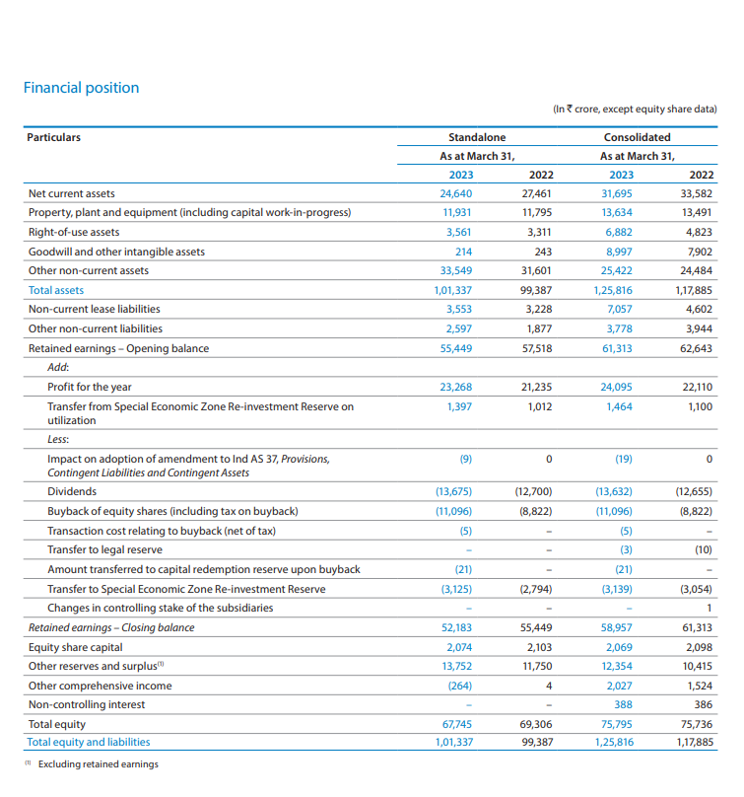

For the year 2021-2022

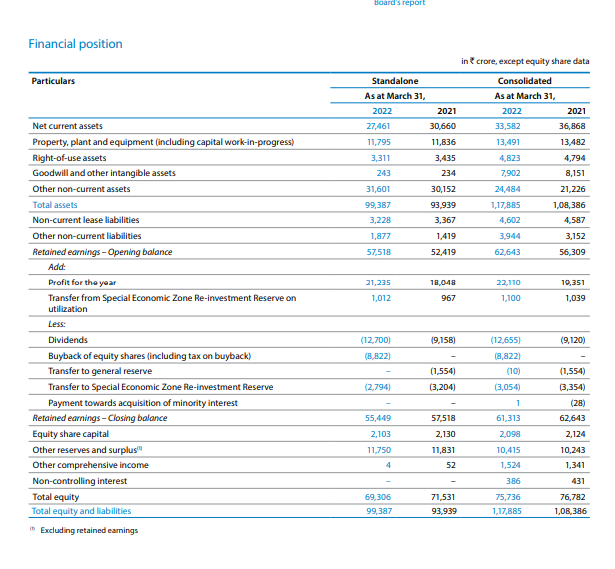

**INVESTMENT DECISIONS:**

FOR THE YEAR 2022-2023:

The changes in the carrying value of property, plant and equipment for the year ended March 31, 2023 are as follows:

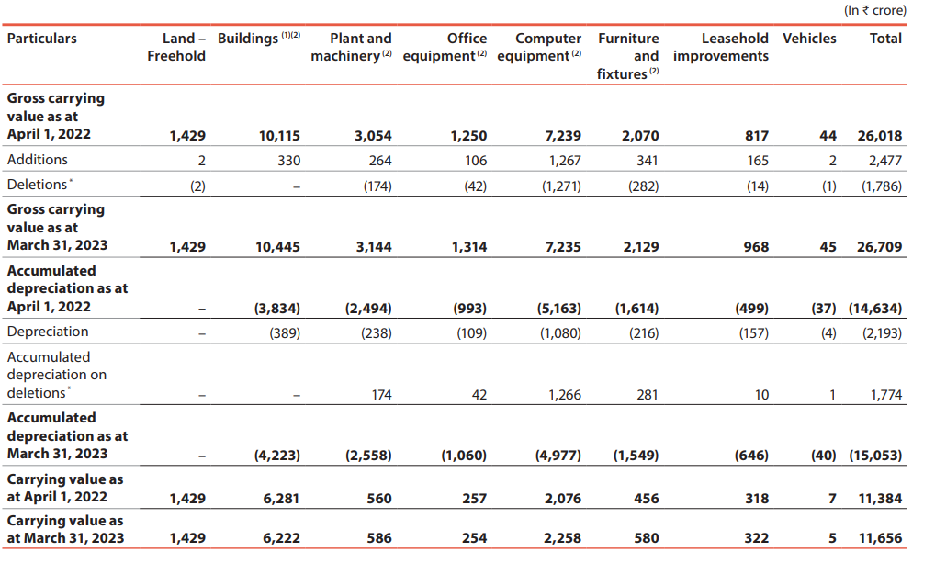

During the year ended March 31, 2023, certain assets which were not in use having gross book value of ₹1,598 crore (net book value: nil), were retired.

In the year 2023 Infosys spend 1,208 crore on Infrastructure and 2 crore on computer equipment and 1,267 crore on Vehicles.

Hence total 2,477 crore.

In the year 2022 Infosys spend 1,100 crore on Infrastructure and 1,281 crore on computer equipment.

Hence total 2,381 crore.

FOR THE YEAR 2021-2022:

The changes in the carrying value of property, plant and equipment for the year ended March 31, 2022 were as follows:

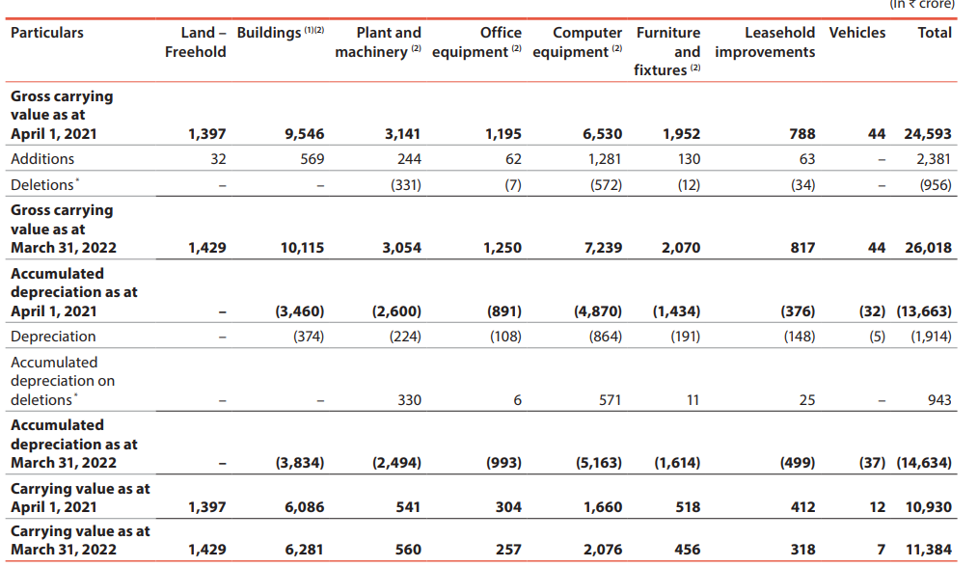

During the year ended March 31, 2022, certain assets which were not in use having gross book value of ₹291 crore (net book value: nil) respectively, were retired.

Buildings include ₹250 being the value of five shares of ₹50 each in Mittal Towers Premises Co-operative Society Limited.

On a standalone basis, additions to tangible assets was`2,381 crore. This comprises `1,100 crore in infrastructure and `1,281 crore for investment in computer equipment.

on a consolidated basis, additions to tangible assets was `2,716 crore. This comprises `1,174 crore in infrastructure and `1,542 crore in computer equipment.

**FINANCING DECISION**

FOR YEAR 2021-2023:

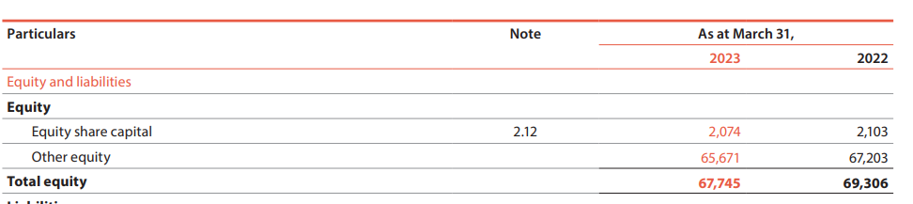

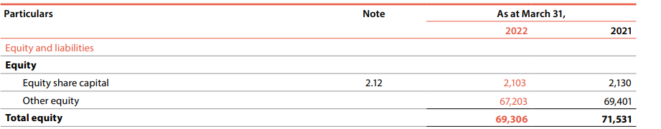

Infosys have one class of shares – equity shares of par value ₹5 each. During the year, 2022-2023, the movement in share capital was primarily on account of buyback of 6,04,26,348 shares resulting in a cash outflow of ₹9,300 crore

Infosys have one class of shares – equity shares of par value `5 each. During the year 2021-22, the movement in share capital was primarily on account of buyback of 5,58,07,337 shares resulting in a cash outflow of `9,200 crore.

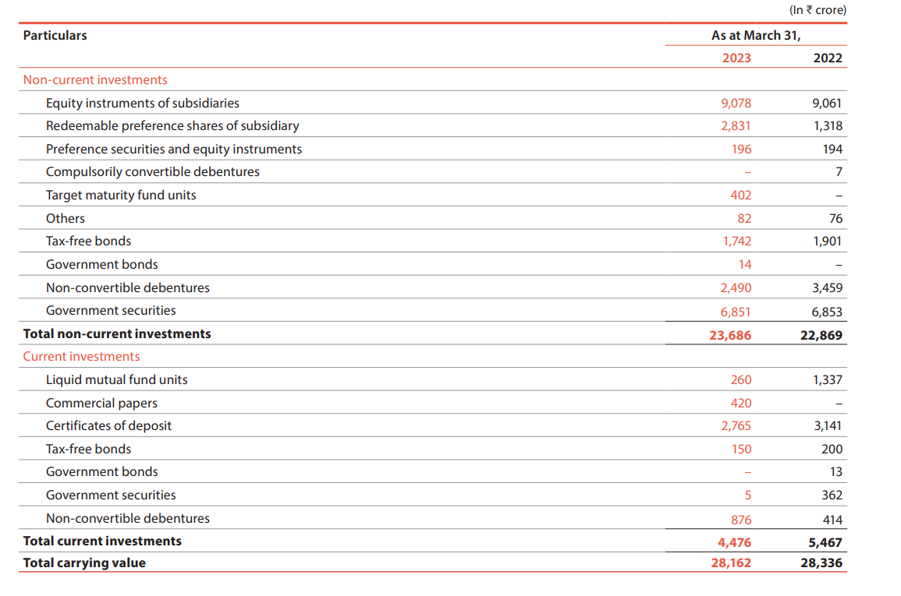

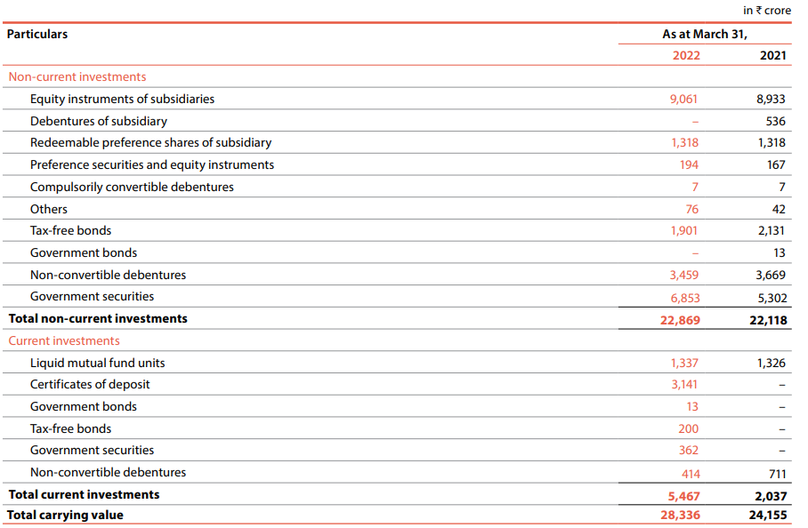

FOR YEAR 2022-2023:

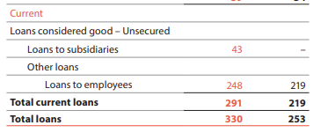

FOR YEAR 2021-2022:

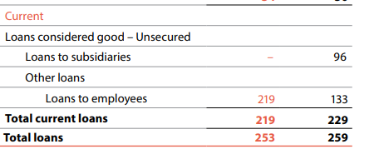

FOR YEAR 2021-2023:

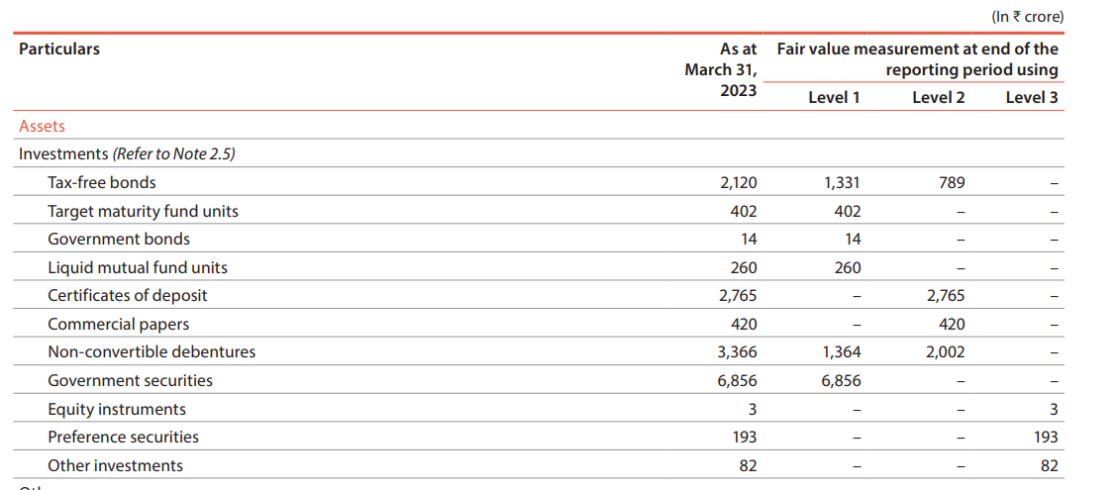

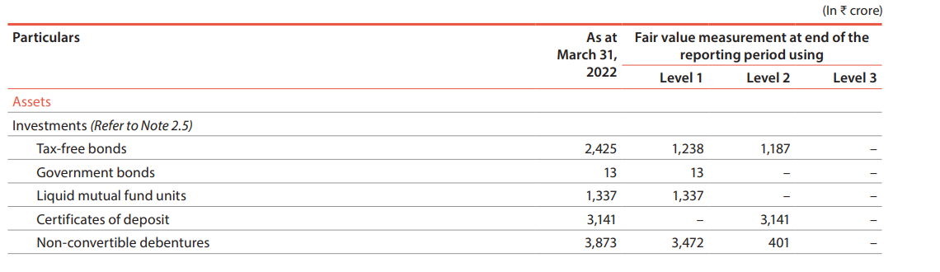

**DIVIDEND DECISIONS**

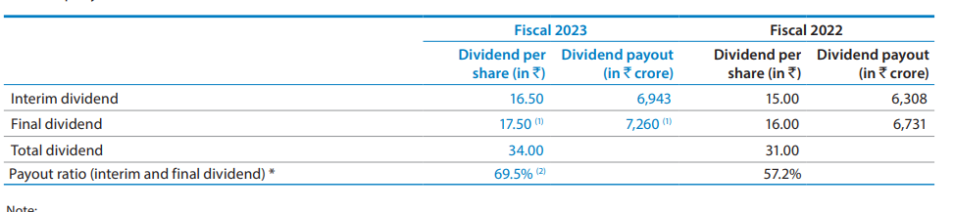

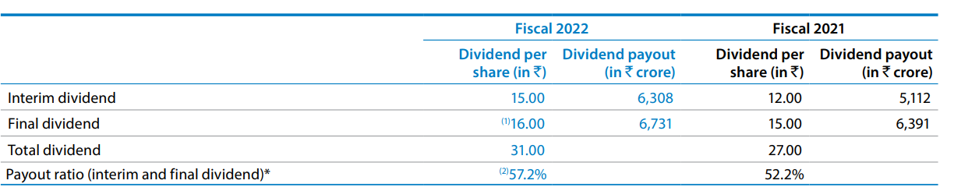

The ratios for the years ended March 31, 2023 and March 31, 2022 are as follows:

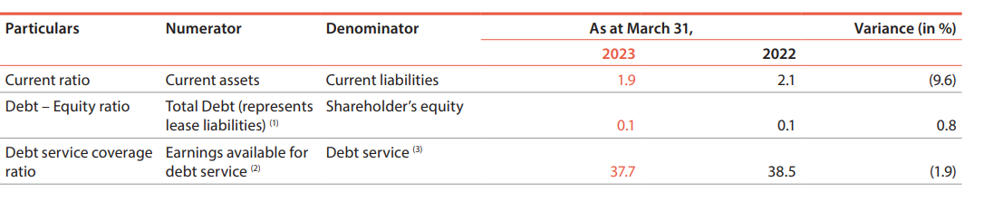

According to Fiscal 2022 the dividend=interim dividend + final dividend

15.00+16.00=31.00

According to Fiscal 2023 the dividend=interim dividend + final dividend

12.00+15.00=27.00

The total dividend have decreased in one year.

During the year ended March 31, 2023, the Company paid an interim dividend of ₹16.5 per share and announced a final dividend of ₹17.5 per share.

**LIQUIDITY DECISIONS**

CURRENT ASSERTS AND CURRENT LIABILITIES FOR 2022-2023:



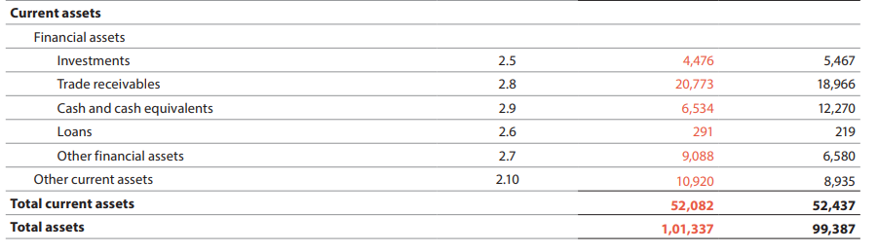

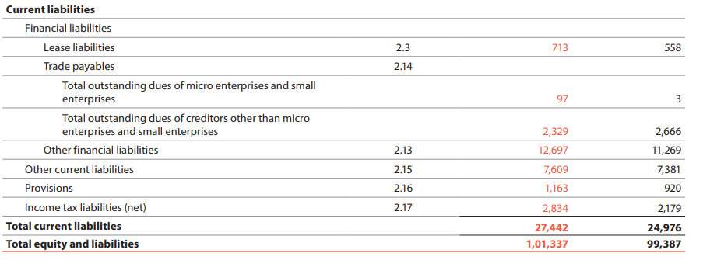

As of March 31, 2023, Infosys had ₹24,640 crore in working capital on a standalone basis, and ₹31,695 crore on a consolidated basis.

Consolidated cash and investments stand at ₹22,509 crore on a standalone basis and ₹31,286 crore on a consolidated basis as on March 31, 2023, as against `29,950 crore on a standalone basis, and `37,419 crore on a consolidated basis as on March 31, 2022.

CURRENT ASSERTS AND CURRENT LIABILITIES FOR 2021-2022:



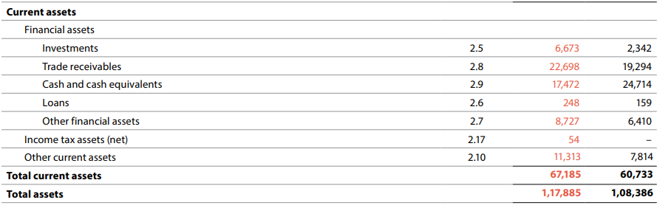

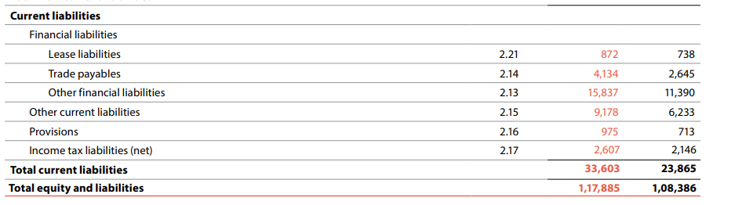

As of March 31, 2022, we had `27,461 crore in working capital on a standalone basis, and `33,582 crore on a consolidated basis.

Consolidated cash and investments stand at `29,950 crore on a standalone basis and `37,419 crore on a consolidated basis as on March 31, 2022, as against `30,764 crore on a standalone basis, and `38,660 crore on a consolidated basis as on March 31, 2021

As at March 31, 2023 and March 31, 2022, 2,24,924 and 2,65,561 cash-settled options were outstanding, respectively. The carrying value of liability towards cash-settled, share-based payments was ₹4 crore and ₹13 crore as at March 31, 2023 and March 31, 2022, respectively.

**SHARE PRICE FOR TWO YEARS (2021-2023)**

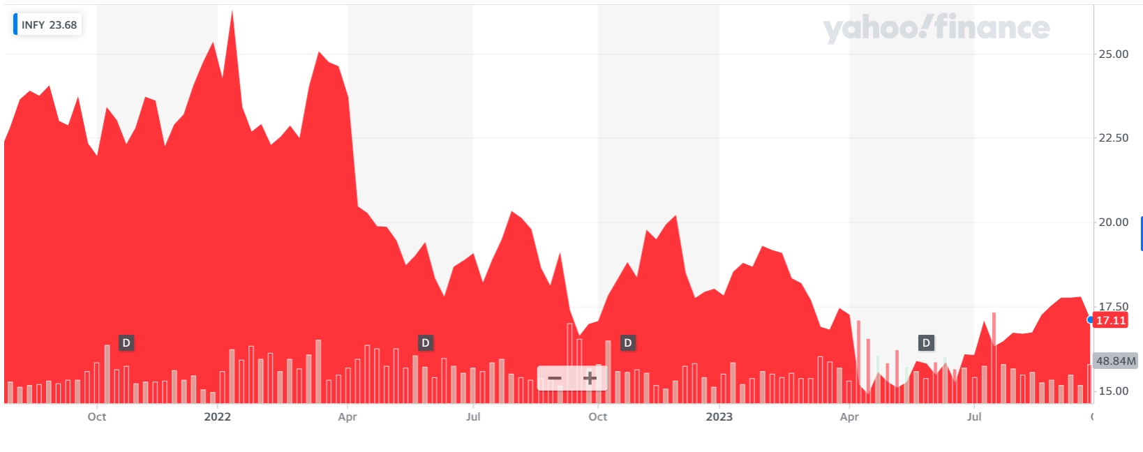

**ANALYSIS**

75,407 crores Net assets  31,286 crores Consolidated cash and investment and 15.4% Constant currency revenue growth 9.7% Earnings per share growth 31.2%Return on equity. Hence there is a Profitable growth Sustained / long-term cash flow.

In fiscal 2023, the Company received ₹1,463 crore of dividend from our subsidiary, which is reflected in the Standalone financial statements

Interest income in fiscal 2023 has increased as compared to fiscal 2022 primarily due to a increase in yield on investments.

The selling and marketing expenses on standalone basis have remained unchanged as a percentage of revenue during fiscal 2023 at 4.0%, and have increased on consolidated basis during fiscal 2023 to 4.3% from 4.2% in fiscal 2022, mainly on account of increase in branding and marketing expenses and travelling costs partially offset by decrease in employee benefit costs.

Where as cash flows have decreased in fiscal 2023 as compared to fiscal 2022 mainly on account of outflow in working capital and higher income tax payments.

Net profit has increased from ₹22,110 crore to ₹24,095 crore on a consolidated basis and from ₹21,235 crore to ₹23,268 crore on a standalone basis. Average net worth has not increased in line with increase in net profit on account of share buyback and dividend.

As of March 31, 2022, the Company has only one class of equity shares and has no debt. Consequent to the above capital structure, there are no externally imposed capital requirements.

So as per the analysis the give decisions may give the positive impact on the company.

Total revenue ,cost of revenue, and earnings per share value may increase.